**PROJECT OOP**

**PADA SISTEM INFORMASI (APLIKASI)**

**ABSENSI SMKN 1 KARANG BARU**

**Dengan Pendekatan OOP**



**OLEH:**

**MEYLISA EKA PUTRY**

**NISN. 0087452208**

**REKAYASA PERANGKAT LUNAK**

**SMK NEGERI 1 KARANG BARU**

**PEMERINTAH PROVINSI ACEH**

**2025**

**DESAIN ERD (KONSEPTUAL)**

**ERD Bengkel komputer Sebelum Normalisasi**



**ERD Bengkel komputer Setelah Normalisasi**



**DESAIN LOGIKAL**

Desain logikal yaitu proses pembuatan model dari informasi yang digunakan perusahaan berdasarkan model dan data spesifik. Deskripsi implementasi *database* berdasarkan hasil desain logikal dengan *Entity Relationship Diagram* (ERD) pada *Database Management System* (DBMS) menghasilkan ERT sebagai berikut



**DESAIN FISIKAL & SOURCE SQL**

**Tabel pegawai**

|  |  |  |  |  |  |  |
| --- | --- | --- | --- | --- | --- | --- |
| **No** | **Nama kolom** | **Tipe data** | **Lebar** | **Null** | **kunci** | **keterangan** |
|  | **idpegawai** | Int | 11 | Not null | Primary key | Auto increment |
|  | namapegawai | vachar | 30 |  |  |  |
|  | nip | number | 30 |  |  |  |

create table pegawai (

idpegawai int(11)primary key not null auto_increment,

namapegawai varchar (30),

nip varchar (20),

primary key(idpegawai),

);

**Tabel admin**

|  |  |  |  |  |  |  |
| --- | --- | --- | --- | --- | --- | --- |
| **No** | **Nama kolom** | **Tipe data** | **Lebar** | **Null** | **kunci** | **keterangan** |
| 1 | **Idadmin** | Int | 11 | not null | primaryKey | auto increment |
| 2 | namaadmin | varchar | 30 |  |  |  |
| 3 | username | varchar | 100 |  |  |  |
| 4 | password | varchar | 30 |  |  |  |

create table admin (

idadmin int(11)not null auto_increment,

namaadmin varchar (30),

username varchar (100),

password varchar (30),

primary key(idadmin),

);

**Tabel absensi**

|  |  |  |  |  |  |  |
| --- | --- | --- | --- | --- | --- | --- |
| **No** | **Nama kolom** | **Tipe data** | **Lebar** | **Null** | **kunci** | **keterangan** |
| 1 | **Idabsensi** | int | 11 | not null | primarykey | auto increment |
| 2 | *Idadmin* | int | 11 |  | foreignkey |  |
| 3 | *Idpegawai* | int | 11 |  | foreignkey |  |
| 4 | tanggal | date |  |  |  |  |
| 5 | jammasuk | time |  |  |  |  |
| 6 | jamkeluar | time |  |  |  |  |
| 7 | keterangan | enum | izin,alpha |  |  |  |

create table absensi (

idabsensi int(11) not null auto_increment,

idadmin int(11),

idpegawai int(11),

tanggal date ,

jammasuk time,

jamkeluar time,

keterangan enum(“izin”,”alpha”),

primary key(idabsensi),

constraint idadmin foreign key (idadmin) references admin (idadmin),

constraint idpegawai foreign key (idpegawai) references pegawai (idpegawai) );

**Hasil Desain Konseptual Skema Relasi Database Di Phpmyadmin**

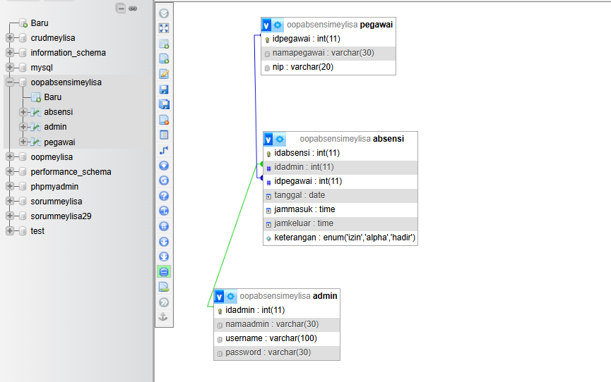

**­­­APLIKASI**

|  |  |  |  |  |  |  |  |
| --- | --- | --- | --- | --- | --- | --- | --- |
| **Fitur** | **Pendukung** | **Urgensi/Tingkat Kepentingan** | | | | | |
| **Create** | **Read (tampil)** | **Update** | **Delete** | **Printout** | **Pencarian** |
| Pengguna/Admin | no | perlu | perlu | perlu | perlu | perlu | perlu |
|  | namaadmin | perlu | perlu | perlu | perlu | perlu | perlu |
|  | username | perlu | perlu | perlu | perlu | perlu | perlu |
|  | password | perlu | perlu | perlu | perlu | perlu | perlu |
| Pegawai | no | perlu | perlu | perlu | perlu | perlu | perlu |
|  | namapegawai | perlu | perlu | perlu | perlu | perlu | perlu |
|  | nip | perlu | perlu | perlu | perlu | perlu | perlu |
| Absensi | no | perlu | perlu | perlu | perlu | perlu | perlu |
|  | namapegawai | perlu | perlu | perlu | perlu | perlu | perlu |
|  | namaadmin | perlu | perlu | perlu | perlu | perlu | perlu |
|  | tanggal | perlu | perlu | perlu | perlu | perlu | perlu |
|  | jammasuk | perlu | perlu | perlu | perlu | perlu | perlu |
|  | jamkeluar | perlu | perlu | perlu | perlu | perlu | perlu |
|  | keterangan | perlu | perlu | perlu | perlu | perlu | perlu |
|  |  |  |  |  |  |  |  |

**Fitur Index/Home/Dashboard**

**Fitur Admin**

Controller & Model

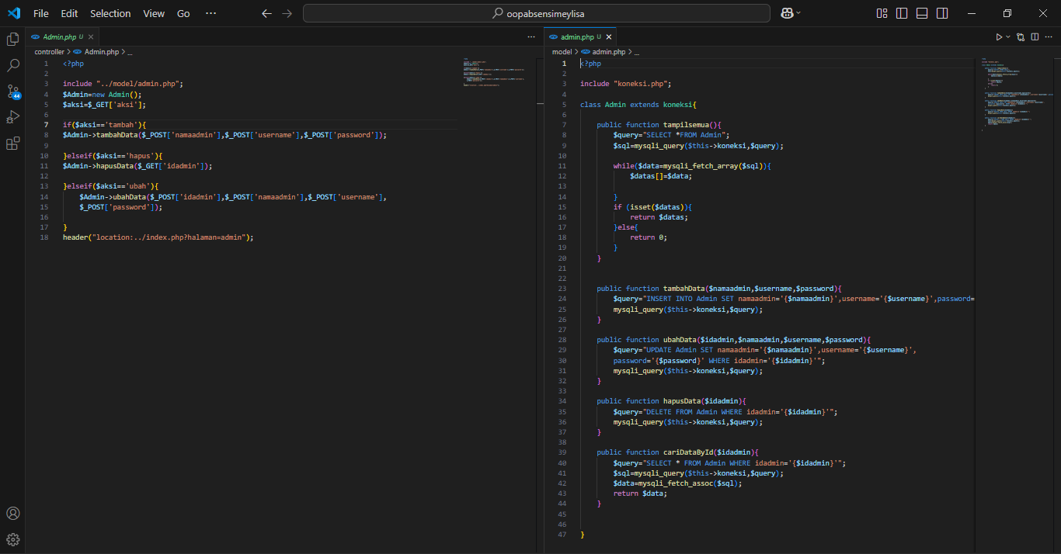

Views->Tampil

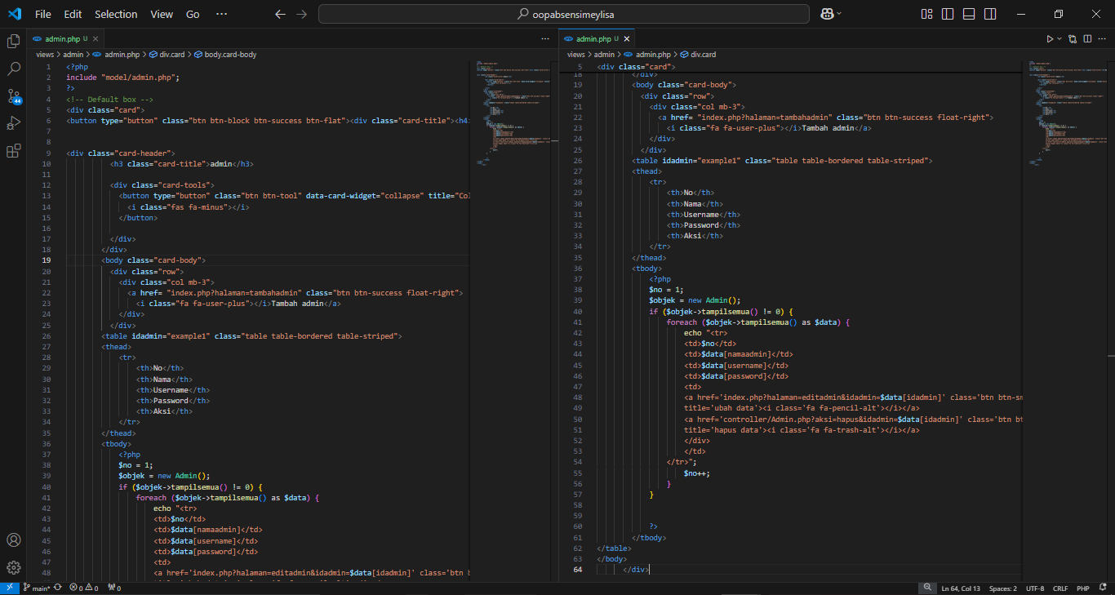

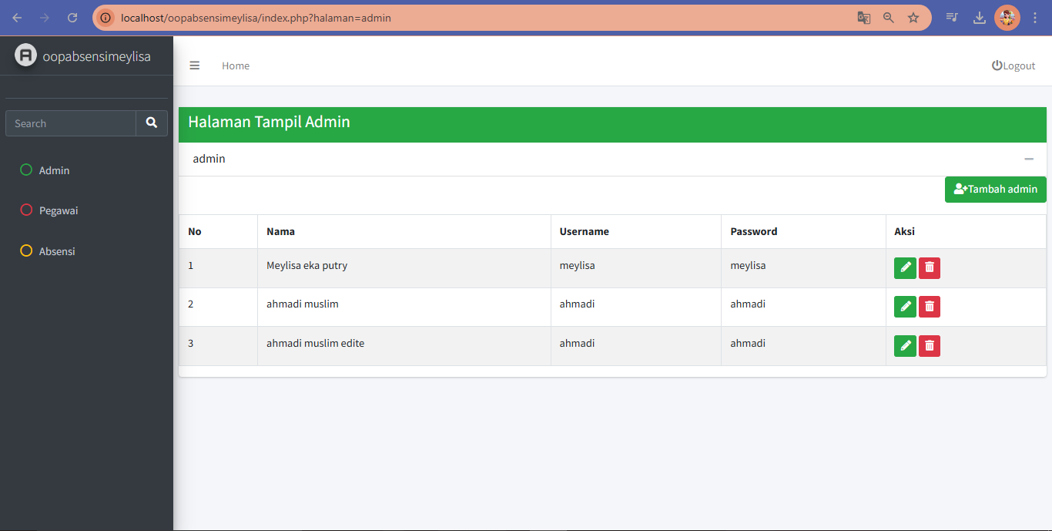

Views->Tambah

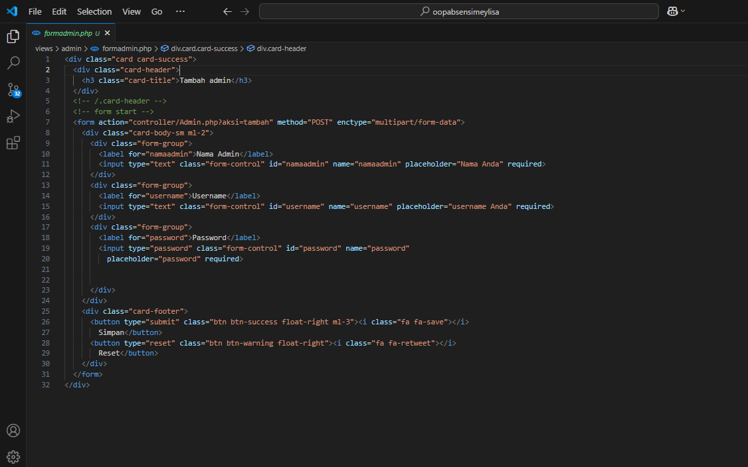

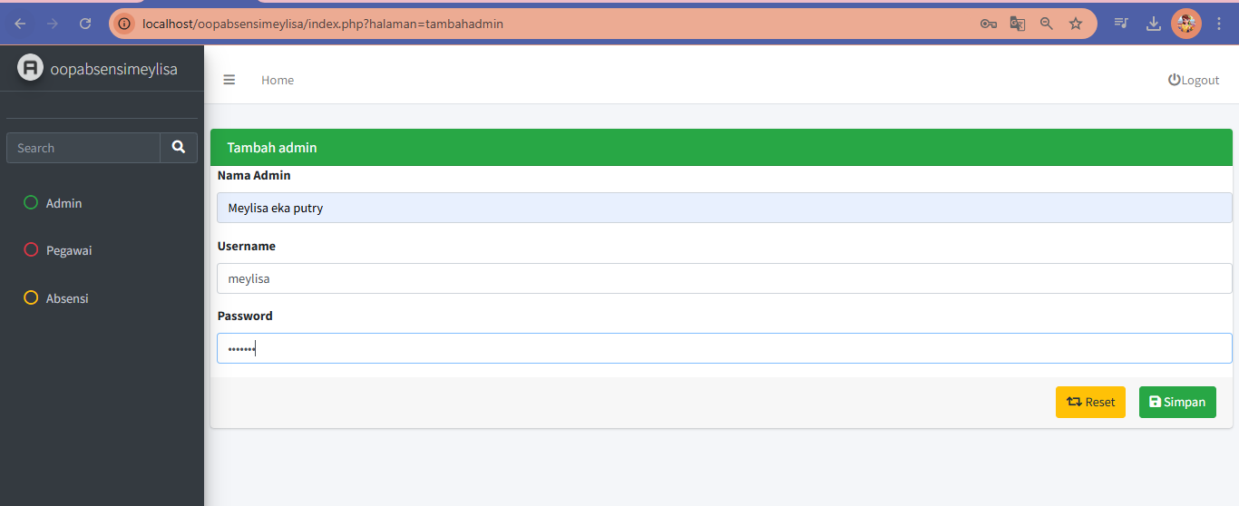

Views->Edit

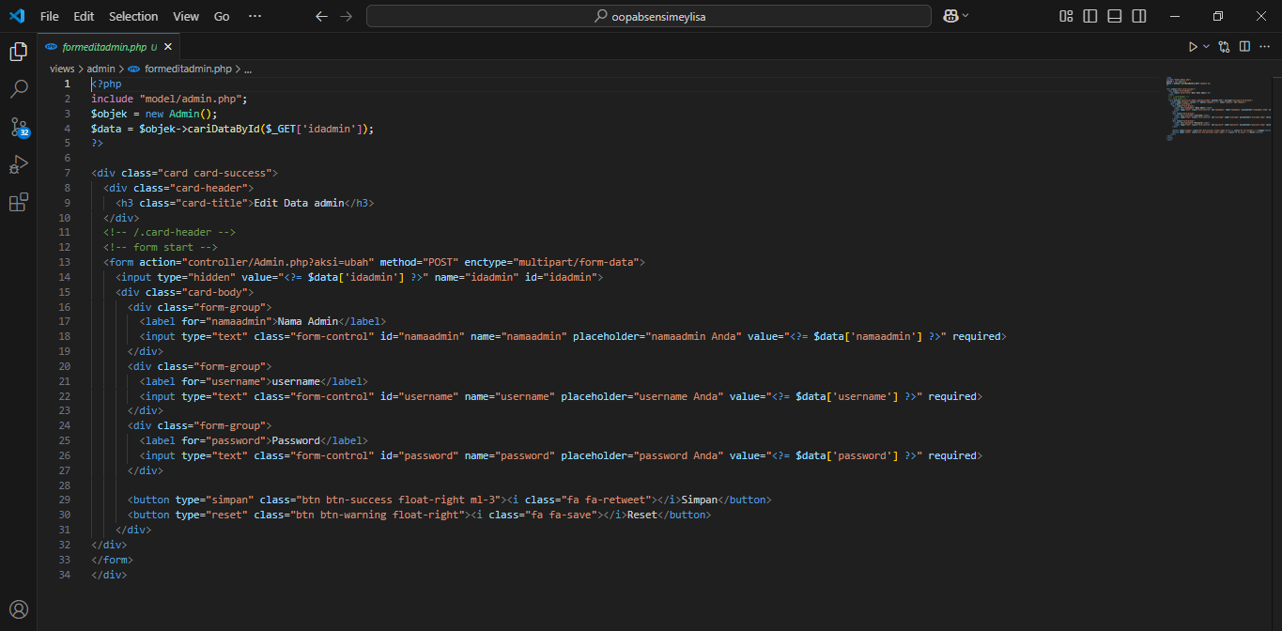

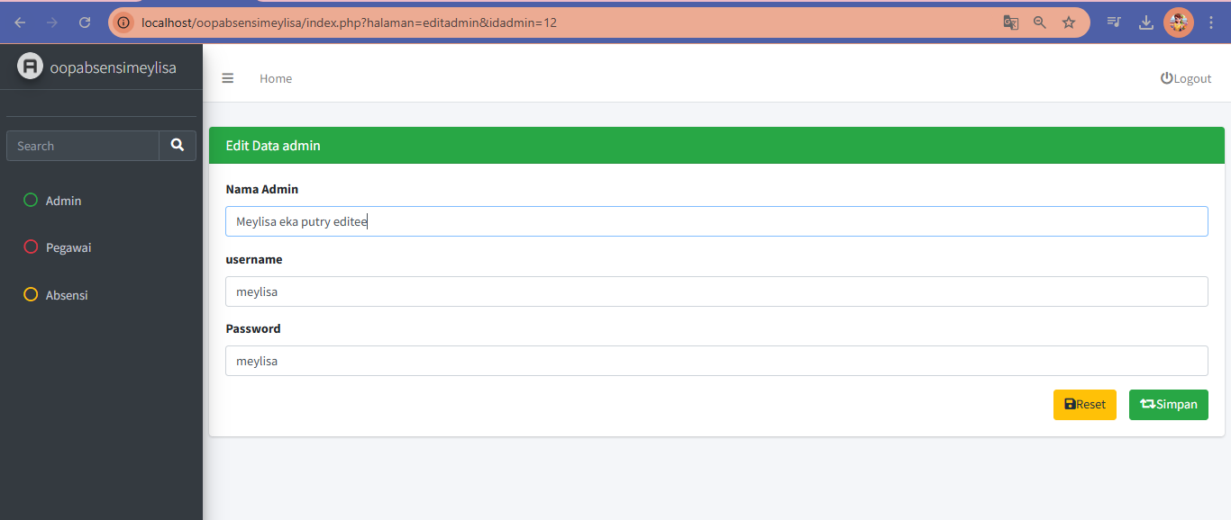

**Fitur Pegawai**

Controller & Model

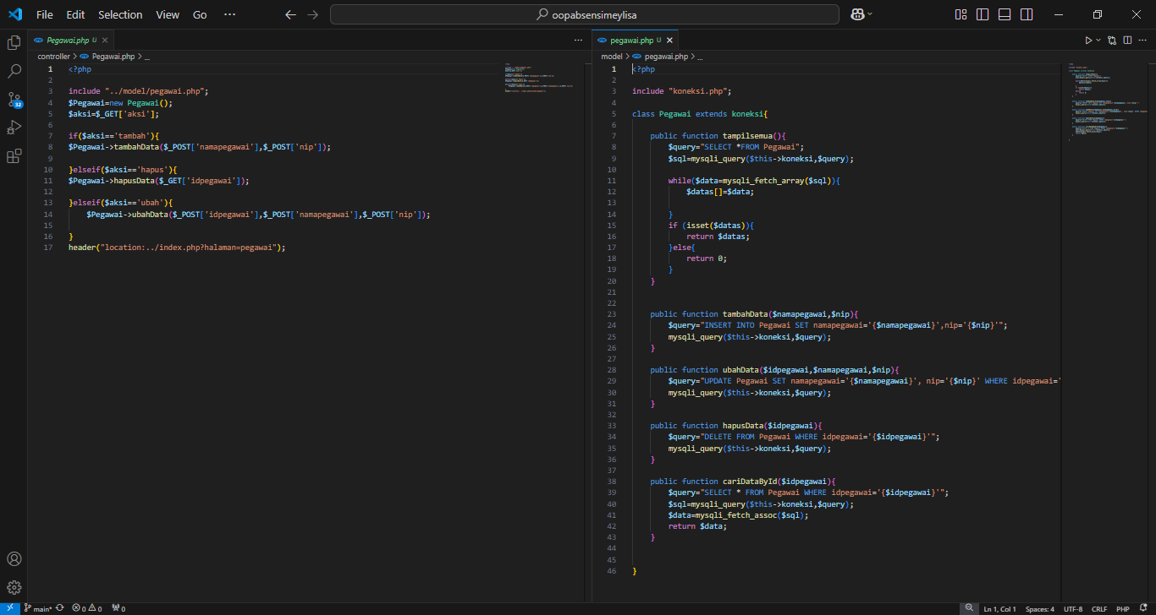

Views->Tampil

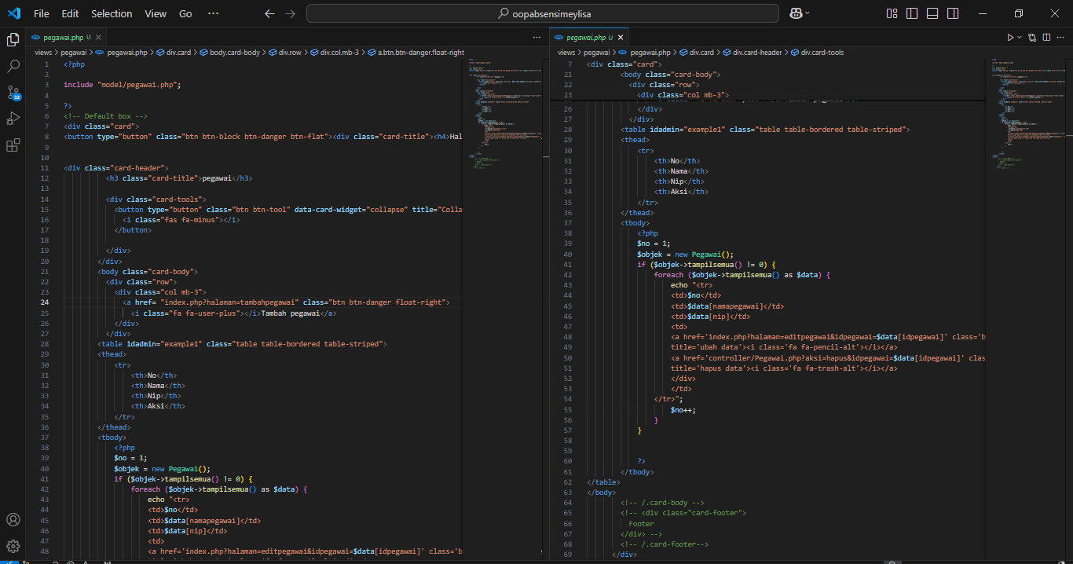

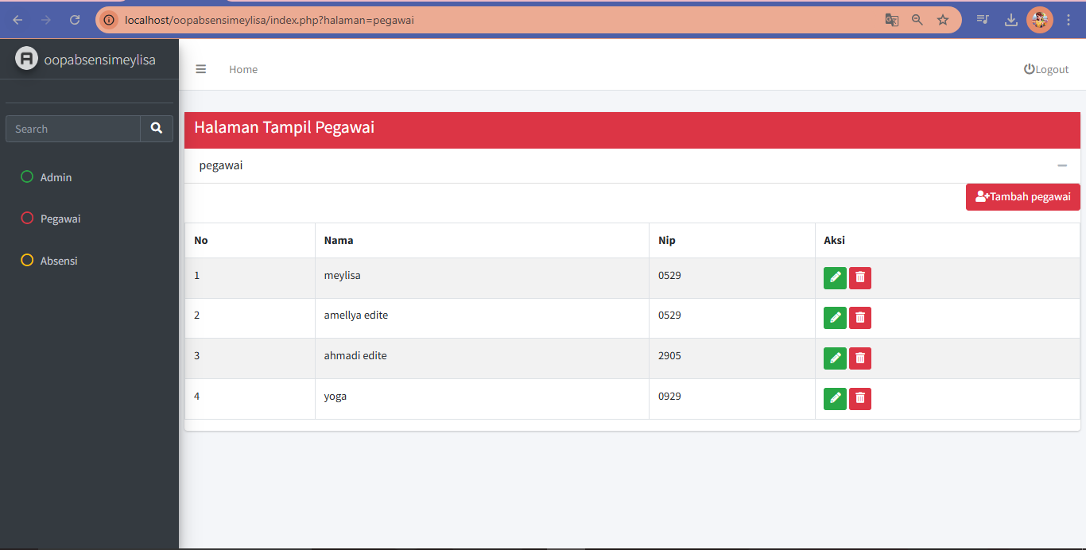

Views->Tambah

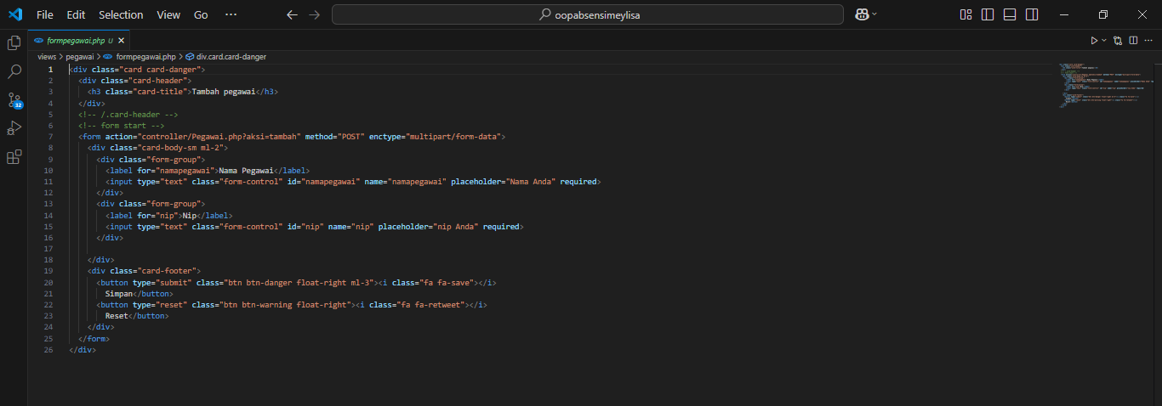

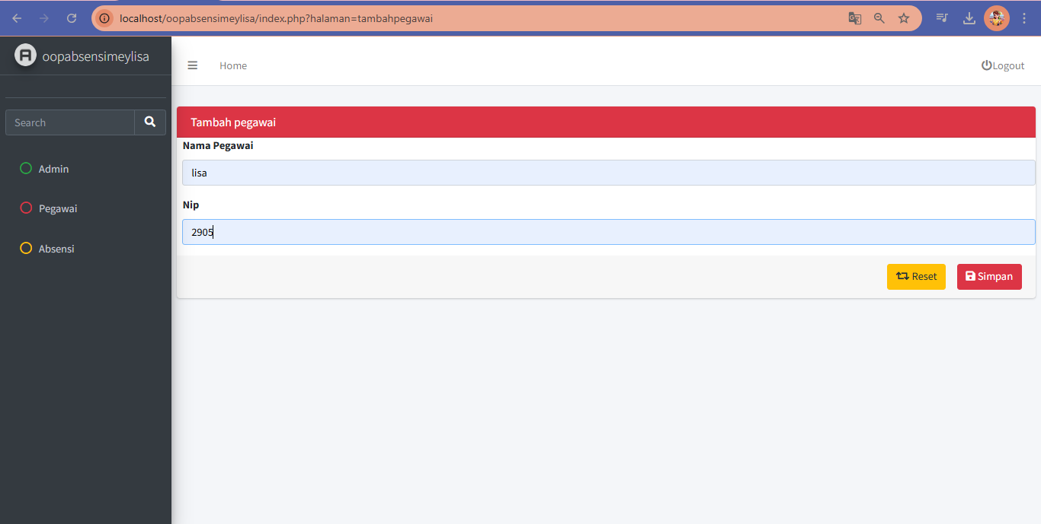

Views->Edit

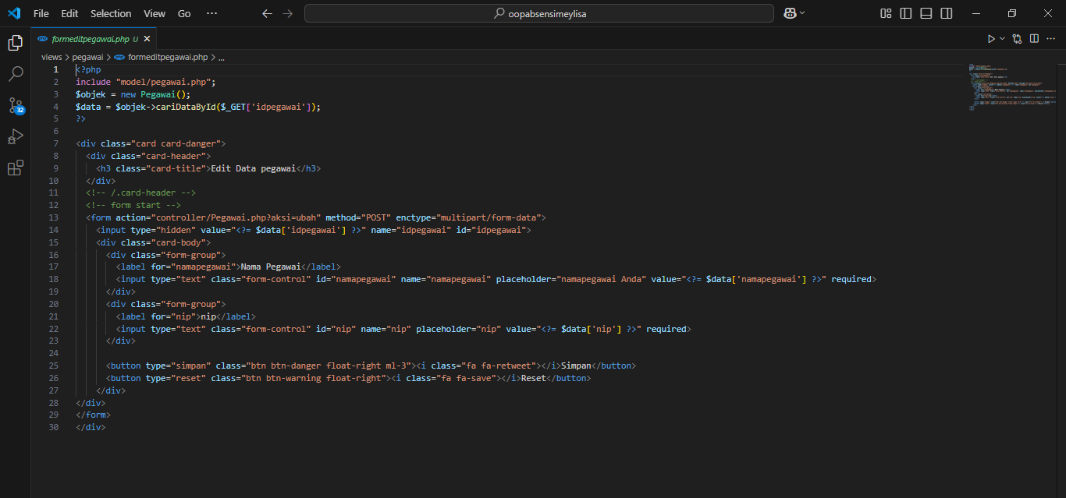

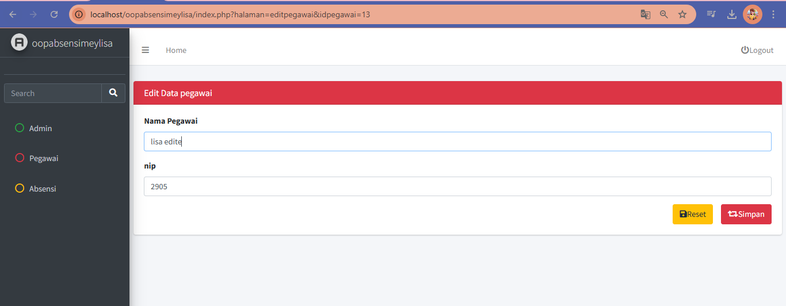

**Fitur Absensi**

Controller & Model

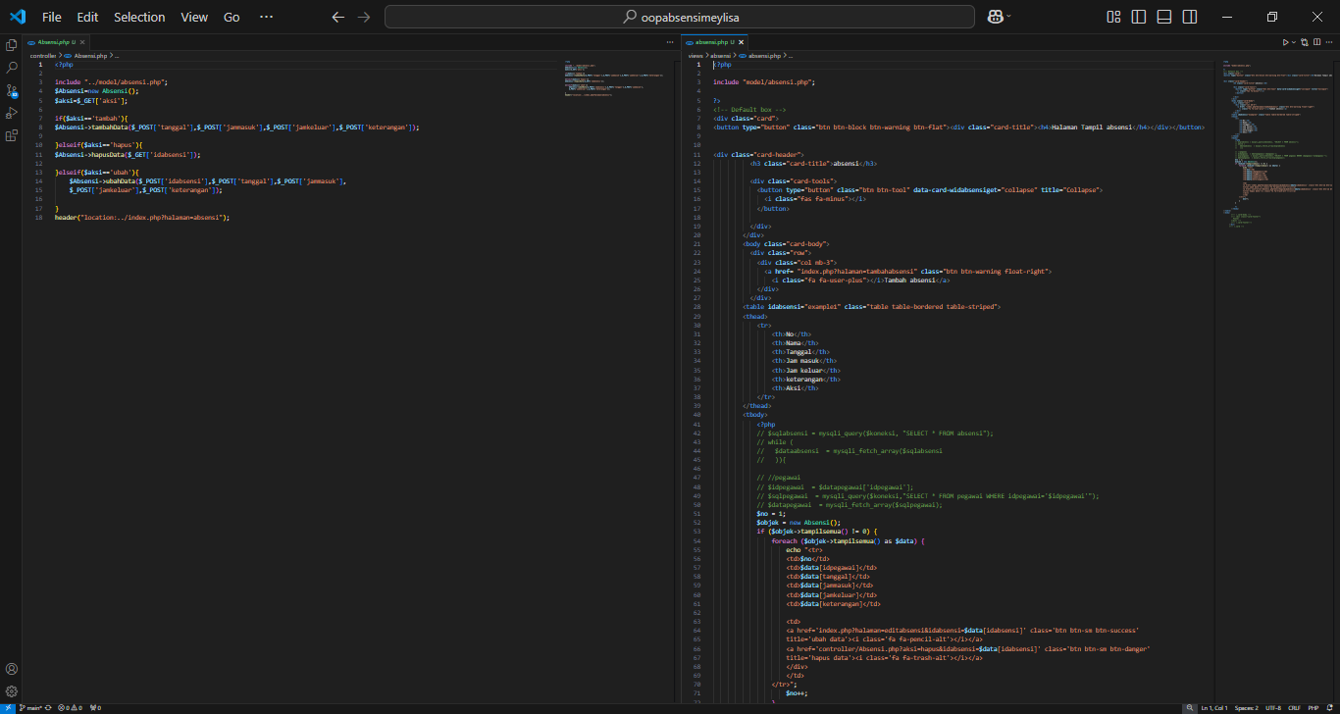

Views->Tampil

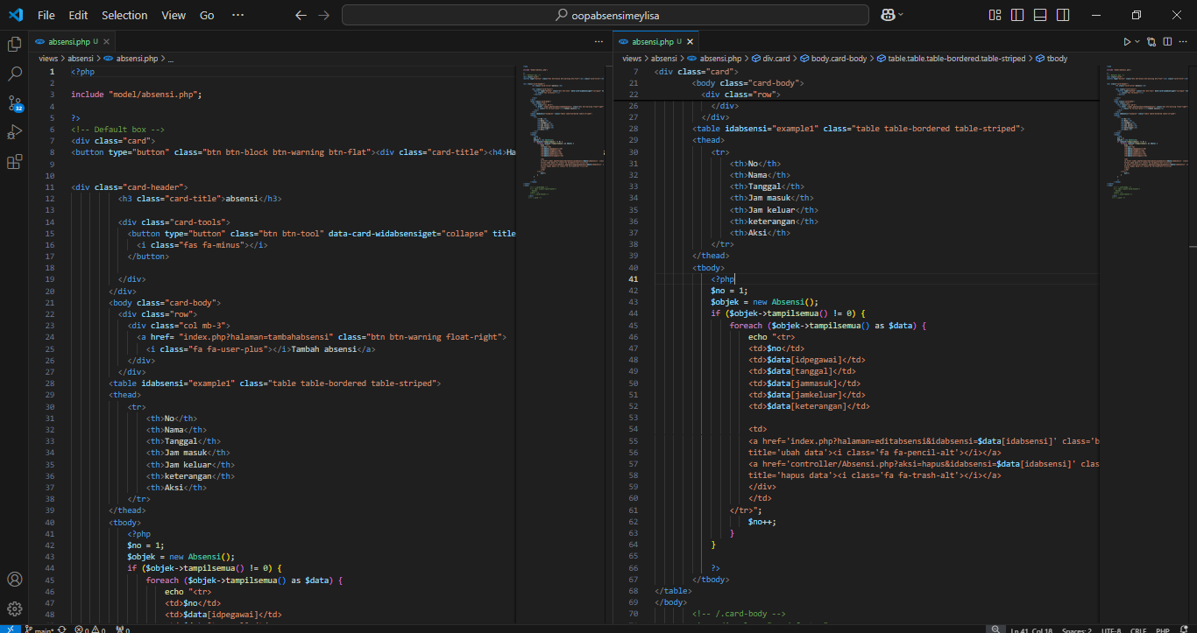

Views->Tambah

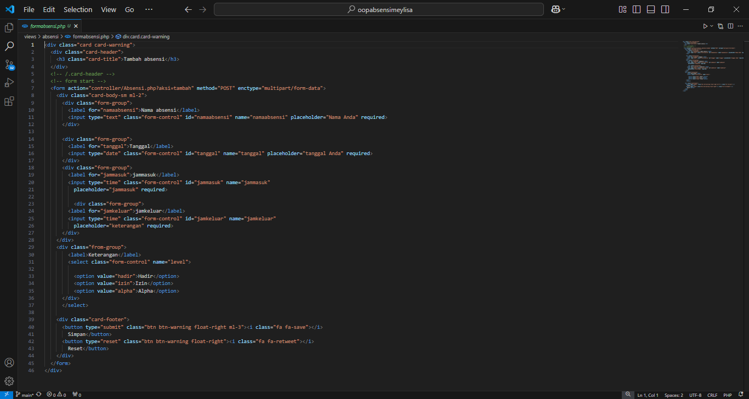

Views->Edit

